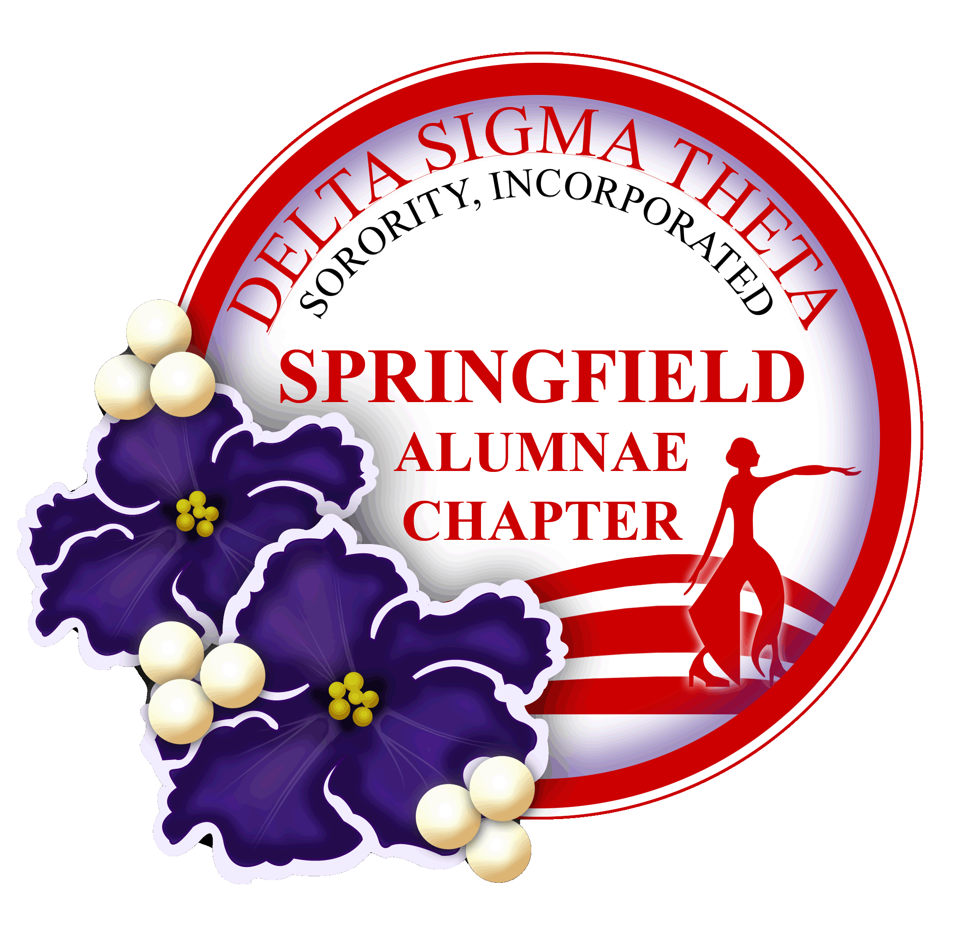
2023-2024 Scholarship

ANNOUNCEMENT

The Springfield Alumnae Chapter of Delta Sigma Theta Sorority, Inc. is accepting applications for a scholarship for academic study from young African American women from the Greater Springfield and Pioneer Valley areas. The successful applicant will meet the following criteria:

- Be a senior in high school
- Provide proof that she has been admitted to a four-year institution of higher learning.
- Have a minimum of a “3.0/B” grade point average in high school; or equivalent
- Submit one official copy of her high school transcript; with official GPA*
- Submit two letters of recommendation (one from a teacher);
- Fully complete the application and essay.
- Indication of Community Service and Leadership Skills
- Provide a Color Headshot with this application. The picture will only be used if you are selected for the Scholarship Award for promotional purposes only. All others will be returned to you.
- Interview with Scholarship Committee.
- Be present at the Scholarship Award Luncheon in May 2024

An interview with the scholarship committee of the Springfield Alumnae Chapter of Delta Sigma Theta Sorority, Inc. is required of qualified applicants in the week of April 18, 2024.

The deadline for applications is March 1, 2024. Applications as well as official transcripts, college acceptance letters, and letters of recommendation should be emailed to the following address no later than March 10, 2023: SACPresident1981@gmail.com

*Springfield Public Schools students: To ensure that you receive your transcript to submit a complete scholarship packet by the deadline, it is advised that you request your transcript from your school counselor.*

Applications and required information emailed after the above deadline will not be considered. Incomplete applications will also not be considered. For further information, please contact Ms. Kimberley Strother at SACPresident1981@gmail.com

